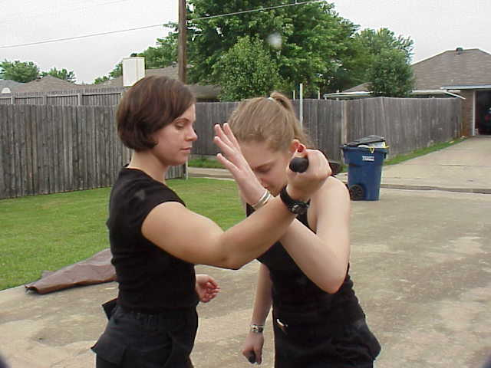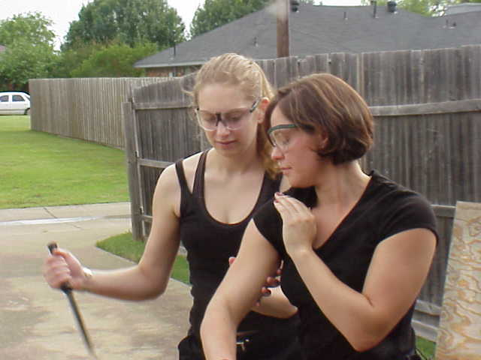

The Dallas Pekiti Tirsia Kali Club has started classes designed for women who are interested in a Martial Art and cross training.
Women cross training in a Martial Art
Kali is a Filipino martial art system that derives its techniques from edged weapons. Pekiti Tirsa is a close quarter kali system that is effective, easy to learn and does not take forever to become effective. The training progression is from practice stick to short blade (knife) to emptyhand work. Simple aerobic footwork coupled with hand movements from ancient Filipino traditions of the Tortal family, put to a musical beat develops timing, body awareness, and rhythm along with a cardio workout. The workout also provides for a combat effectiveness that can find application in those unexpected places that one does not particular want to finds oneself in.

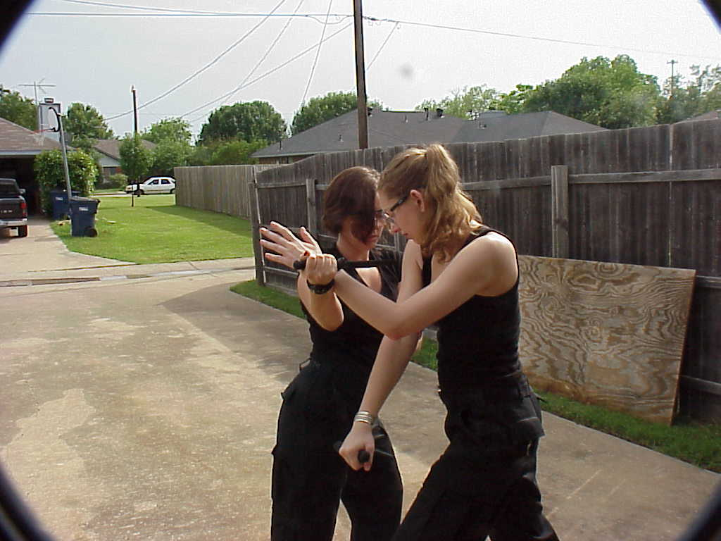

The Dallas Recreation Center is at 6906 Churchill Way, Dallas. For information contact Paul Taylor (817) 239-2338: taylorp@dallas.net or www.bladefighting.com On Monday nights from 6 to 7 pm. $50 / month, Monday-Wednesday 6:00-7:30 PM

